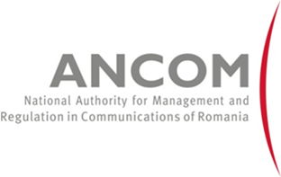

ERGP Stakeholders Workshop
on the
Implementation of the Universal Service Obligation in the postal sector
in view of the market developments
19 November 2014, Athénée Palace Hilton Bucharest

Time | Programme | Actors
13:00 – 13:30 | Registration
13:30 – 13:35 | Welcome and introduction | Cătălin MARINESCU, ANCOM  (ERGP 2014 Chair)
13:35 – 13.45 | Presentation of the Discussion Paper and questions | Camilla SEBASTIANI, AGCOM  Co-chair of ERGP “Subgroup on net costs of USO and VAT exemption”
13:45 – 15:00 | Stakeholder Dialogue | Moderator: Jack HAMANDE, BIPT, ERGP 2014 Vice Chair
15:00 – 15:15 | Coffee break
15:15 – 16:30 | Stakeholder Dialogue | Moderator: Jack HAMANDE, BIPT, ERGP Vice Chair
16:30 – 16:45 | Coffee break
16:45-17.00 | Rapporteur 1 will present the major stakeholder inputs from Section 1 | Rapporteur 1: Camilla SEBASTIANI, AGCOM, Co-chair of ERGP “Subgroup on net costs of USO and VAT exemption”
17:00-17.15 | Rapporteur 2 will present the major stakeholder inputs from Section 2 | Rapporteur 2: Lars FORSLUND, PTS, Co-chair of  ERGP “Subgroup on net costs of USO and VAT exemption”
17:15 – 17:30 | Conclusions and closing | Cătălin MARINESCU  (ERGP 2014 Chair)

