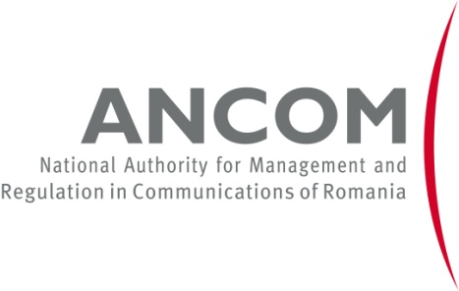

Knowledge is Power:
Information Tools for Telecom Consumers
May 27, 2014, Marriott Hotel, Bucharest

More and more people become multiple and intensive communications users as they have access to more and more services in increasingly numerous situations and places, ever more available, ever more appealing. Every day they are getting more skilful at configuring gadgets, interconnecting platforms and obtaining access. But are the consumers equally proficient when it comes to getting the information they need in order to protect their rights? 5 years after its first conference dedicated to the rights of the users of electronic communications services, ANCOM brings this theme to the public attention once more.
Registration, welcome coffee | 8.30-9.00
Opening speech  Cătălin MARINESCU, President of ANCOM, Romania  Guests of honour  Houlin ZHAO, Deputy Secretary-General, International Telecommunication Union  Răzvan COTOVELEA, Minister of Information Society, Romania | 9.00-9.30
The Consumer – King or Pawn in the Telecommunications Industry?
Consumers are sovereign as long as they know what they want and are able to act upon their desires. If consumers are tricked by limited information or deceitful business practices, then they might not be the rulers of the economic realm. Therefore, it is critical to increase not only the end-users’ trust in the telecom market and its services, but also their confidence that they can make educated decisions.
When and where should authorities intervene in this game? What are the strategic rules they should impose for the game to be fair? Is the current framework enough? Should the end-users themselves change their approach to this game?
The guests of honour in this event will kindly share both their knowledge and experience in this domain that reveals its importance worldwide, and the vision of the bodies they represent, with their specificities and priorities.
Coffee break | 9.30-9.45
The Guiding Lights – Information Tools Developed for Telecom End-Users  Keynote:  Konstantinos Zisis, Policy Analyst - Internet, Market Studies, DG SANCO, European Commission  Panellists:  Danielle JACOBS, President, International Telecommunications Users Group Association, INTUG  Renan MURET, Head of Electronic Communications Services and Consumer Relations, ARCEP, France (TBC)  Federico FLAVIANO, Director, Consumer Protection, AGCOM, Italy  Mario WEBER, M.Sc., Executive Director, HAKOM, Croatia  Bogdan DOSPINESCU, Head of Unit – Universal Service and Tariff Regulations, ANCOM, Romania  Moderator:  Scott Andersen, Deputy Director Biblionet, Romania | 9.45-11.45
Some consumers have the knowledge, skills and time necessary to make their way through the labyrinth of the telecom market, negotiate and get good value for the money they spend. Most of them do not. And regulators believe they should still get the proper service or product. European regulators have developed tools that help consumers make informed decisions.
The speakers will kindly present the applications that help the electronic communications users make informed choices, by detailing both the need they are addressing and the solution they provide, as well as the technical concept and the users’ perception of this solution.
Coffee break | 11.45-12.00
Technology Is Power. Enabling the Disabled  Keynote:  Robin CHRISTOPHERSON, Head of Digital Inclusion, AbilityNet, UK  Panelists:  Sara ANDERSSON, Consumer Market Department, Swedish Post and Telecom Authority  Liviu POPESCU, President, Association of Mobile Operators of Romania  Thomas BARMÜLLER, Director EMEA, Mobile Manufacturers Forum  Moderator:  Mihai CONSTANTIN, TV Producer, Romanian Television Corporation | 12.00-13.35
Speaking of the problems encountered by the disabled users when they use electronic communications services, all the actors in the communications market are aware of the need to find answers and concrete implementation ideas, specific research activities being dedicated therefor. Moreover, the disabled users’ access to the single emergency number features particular importance, by the peculiarities and specific issues involved.
During this session, a representative of the disabled telecom users will kindly tell us about the problems they encounter when using electronic communications services. Then, several solutions to these problems will be discussed. Thus, the panellists are invited to present the applications they developed and implemented, the way they enhanced these solutions in time, the hindrances they encountered, the solutions found and – most important – the users’ reaction to them.
Closing and conclusions  Cătălin MARINESCU, President of ANCOM, Romania | 13.35-13.45
Lunch | 13.45-14.30

Note: The agenda is constantly updated and may be subject to further changes.

