Disclaimer: This is a Romanian to English translation meant to facilitate the understanding of this document. Should differences appear between the Romanian and the English version, following translation, the Romanian version shall prevail.

8. PRIORITY ACTION LINES

  - Optimal Spectrum for 5G
Mobile operators in Romania currently use a total of 770 MHz for the provision of public electronic communications services in their national coverage networks. The frequency bands used are 800 MHz, 900 MHz, 1800 MHz, 2.1 GHz, 2.6 GHz and 3.4-3.8 GHz, with usage rights valid until April 2029 at the latest. The amounts of spectrum held by operators are illustrated in Figure no. 11.

Figure no. 11 - Frequencies used for 2G, 3G and 4G mobile communications and usage rights holders

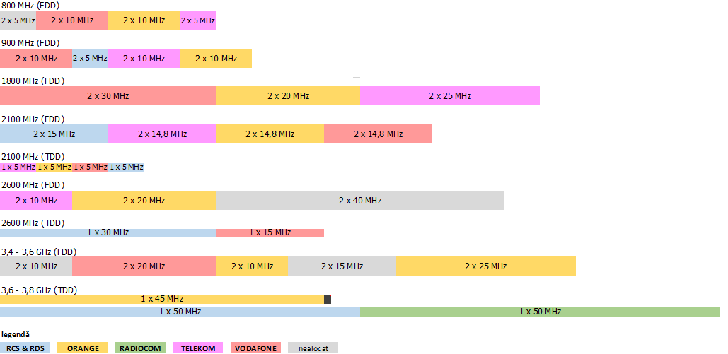
source: ANCOM

Nevertheless, the 5G specific performance - especially in terms of speeds (see Table 2 above) - cannot be achieved with the existing frequency portfolios. Providing speeds of up to 20 Gbps uninterruptedly and reliably, to moving users, requires bandwidths of hundreds of MHz (even up to 1 GHz), a need that can only be fulfilled in mmWave bands.
The 3.4-3.8 GHz frequency band, considered by the RSPG as the most suitable for immediate use of 5G, contains enough spectrum resources, thus setting the premises for providing intensive services for data and applications consumption over small cells in high demand density areas. For 255 MHz in this band, four commercial operators have already acquired technology and service neutral usage rights valid until the end of 2025, with greater flexibility regarding the frequency use plan.

Furthermore, due to their characteristics of propagation over long distances, the frequencies in the 700 MHz band will offer mobile communications operators the opportunity to roll-out 5G coverage over wide areas using the existing infrastructure.

Figure no. 12 – Use case scenarios for key 5G bands
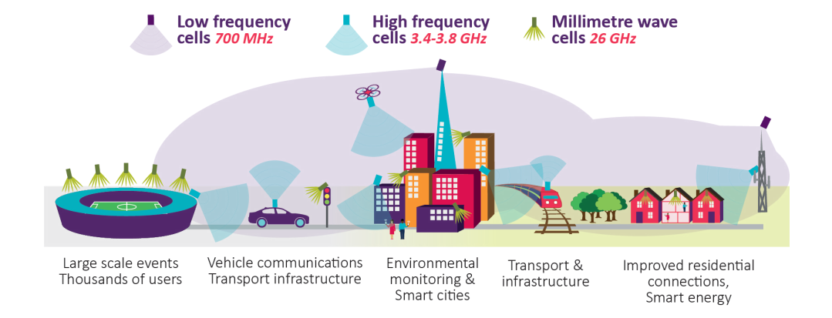
source: Ofcom UK, BNetzA DE

Thus, the 700 MHz, 3.4-3.8 GHz and 24.25-27.5 GHz (26 GHz) bands are key bands for 5G implementation in Romania, similar to the European Union. The first commercial deployments will take place in the 700 MHz and 3.4-3.8 GHz bands, before the end of 2020.

Taking into account the results of EC regulatory process for the 26 GHz band, at least 1 GHz will be made available in the upper range of this band in Romania, by 2021. With a view to benefiting from the WRC-19 results, further GHz amounts in mmWave bands are to be made available.
The use of additional spectrum resources for access networks and the continued upward trend of data traffic consequently requires ensuring appropriate capacities on transport networks, as well. Thus, the demand for fibre optic with a view to connecting the cells to the network can be also satisfied by identifying and allocating new frequency spectrum amounts for radio relay lines, as a priority, for commercial operators. To this end, given the very large bandwidths per radio channel that can be ensured (hundreds of MHz and even up to 1 GHz), high and very high frequency bands are envisaged, i.e. 70/80 GHz bands, which feature good propagation characteristics.
Whenever and if needed, we will take due diligence at government level, through ministries and specialized institutions, including by the use of available mechanisms - including on European level - to support the timely and effective cross-border coordination of 5G radio frequencies, with priority in the bands below 1 GHz and in relation to neighbouring countries that are not members of the European Union.

In the vein of the good policies that foster promoting end-users’ interests and improving the efficiency of spectrum use, investment in 5G spectrum resources will be secured based on auctions (competitive selection procedures). With the aim to promote healthy competitive dynamics in the communications sector, auctions will allow market entry, including in mm wave frequency bands.
Technological progress in the mobile networks’ use of radio frequencies, as well as the new challenges in run-up to the massive development of 5G networks are likely to recommend a rethinking of current models of setting the tariffs for the use of the frequency spectrum in a pro-competitive approach, which should lead decisively to reducing these tariffs.
Moreover, the spectrum resources currently used by public electronic communications networks will be available to be used for 5G as soon as coordination and technical studies are completed.

  - 5G-friendly infrastructures

Benefiting from 5G network performance requires massive private investment from communications operators, and fostering early investment for the achievement of such performance requires providing for an incentivizing, attractive environment. In this respect, the regime established in 2016 for the physical infrastructures of electronic communications networks, as well as for laying down measures to reduce deployment costs, creates favourable conditions for access to public or private property, to the physical infrastructure of the operators of electrical power, public lighting, public transport, communications, natural gas, heat and water, and sewerage networks, of urban public transport services, etc., as well as to the physical infrastructure of railways, road transport (including motorways) networks, ports and airports. The 2016 infrastructure regime also introduces mechanisms to facilitate the co-ordination of works and to make an inventory of communications networks, and of the physical infrastructures of network operators, and lays down the obligation to provide in-built physical infrastructure enabled for high-speed networks within all new or extensively refurbished buildings. The maximum tariffs for the communications networks’ access to public property have recently been set, but other important mechanisms, such as the network inventory or the single information point regarding civil engineering works, are not yet in place.

Mechanisms and regulations for the shared use of physical infrastructure should also stimulate intensive use (the long-term productive efficiency), while avoiding cross-subsidization of users/uses/sectors at the expense of others.
Physical infrastructures used to cover Romania with 4G services are valuable assets that can be further used in the context of the upgrade to 5G, but may not be sufficient to meet the demand for cell densification. Rural macro-cells, and especially metropolitan cells and small cells in the urban area, can share physical infrastructure, starting from towers/pillars/poles to power supplies and fibre optic ducts for network connection. Under these conditions, operators achieve significant efficiency gains, while satisfying urban planning and environmental protection requirements with greater ease.

However, achieving Gigabit speeds and the 5G-specific performance provided in standards requires fibre-optic connection to base stations and traffic concentrators, for the purpose of connecting the cells in urban centres, in suburbs, and in rural areas. 5G traffic growth is estimated to gradually require the densification of urban metropolitan and small cells down to a typical range of 1 km, while rural 5G deployments may be inhibited by the absence of optic fibre infrastructure. Therefore, public interventions to encourage the roll-out of new-generation networks in rural areas can also help to facilitate the deployment of 5G, by the installation of optic fibre or of high-capacity radio-relay links, and by ensuring access to physical infrastructure under favourable technical and economic conditions.

5G performance should be reached not only within a network but also in the communication and traffic exchange between networks, which would usher in the introduction of a national peering obligation during the review of the primary sectoral legislation.

Moreover, the quality parameters can be ensured in the hotspots of cities with high traffic density (such as stadiums, shopping centres, train and airport stations or pedestrian areas) by deploying pico-cells in the 26 GHz band, the range of these so-called "small cells" varying from 20 to 200-300 m depending on the number of users and traffic intensity.

"Small" cells are pieces of equipment too small to be installed on dedicated infrastructures, therefore access to existing infrastructures is essential. Beyond the investment challenges, the proliferation of small cells will increase the difficulty in identifying suitable places for their installation, which will enhance the bargaining power of such site owners in relationship to network providers and may induce the former’s rent-seeking behaviour. Although possible anti-competitive effects of such behaviour can be remedied by regulatory instruments, including those within the scope of competition law, public authority intervention may take various forms, for example by increasing the supply of sites (e.g. street infrastructure, traffic lights, public lighting poles, public transport pillars, etc.).

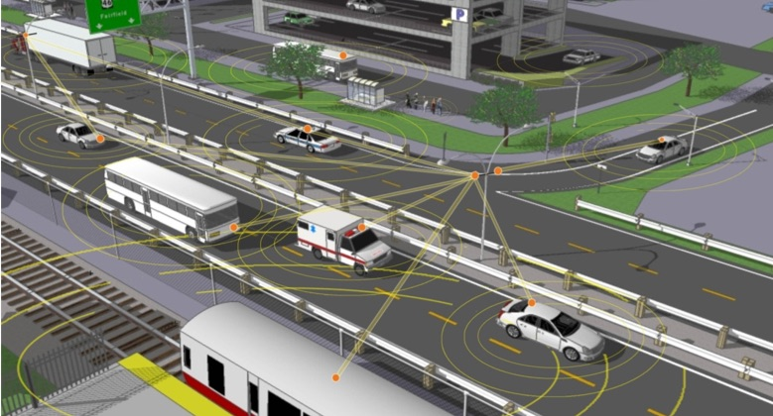
Smart mobility and regional ICT connectivity are strategic objectives of the post-2020 cohesion policy, in Romania and across the Union, and connected and self-driving vehicles are a 5G use case with great development potential and gearing effects. However, given that ensuring latencies of maximum 1 ms involves the installation of a large number of small cells (including their optical fibre connection) along ground-based transport corridors, the need for investment in physical support infrastructure may diminish commercial attractiveness, delaying 5G coverage and inhibiting the development of autonomous transport eco-systems. On the other hand, the design and installation of the physical infrastructure for 5G networks once with the execution of public works on road and railway transport infrastructure, substantially facilitates the development of the autonomous transport ecosystem in Romania. Therefore, it is necessary to design and build physical infrastructures for high-speed and 5G networks along with the works of construction, repair, modernization, rehabilitation or extension of roads (motorways, express roads, national roads, county roads) and railways. In order to minimize implementation costs and increase the efficiency of this obligation, the provision of physical infrastructures for high-speed and 5G networks needs to be planned by joint measures involving decision-makers in several sectors (communications, transport, etc.) as early as possible in the required activity flow, for example in stage of drawing up the feasibility study/technical documentation/terms of reference, but no later than the stage of submitting the application for the issuance of the building permit.

The sustainable development of communications networks implies compliance with the requirements of the authorisation, urban and land planning regimes. In this context, it should be noted that the authorization regime that enables the electronic communications providers’ access to public or private property is an essential factor for network roll-out, while the complexity of processes and delays in granting authorizations can be significant bottlenecks in the development of competition. Significant barriers to 5G network deployment raised by the current regime for the authorisation of construction works (building permits) are a major risk factor for the development of 5G in Romania: it increases the risks and costs of investment projects, ultimately leveraging 5G services and delaying their adoption.
Ensuring the connectivity requirements typical of post-2020 smart cities cannot be reasonably satisfied under the current regime for the authorisation of construction works. The authorization of construction works must evolve in three directions:
- simplification, by removing unnecessary complexities, clarifying processes, reviewing deadlines, transparency and digitization of activities;
- adjusting authorization requirements to technological progress in the execution of construction works, miniaturization of 5G specific infrastructure elements and co-existence/collocation of networks, etc.; there is a justified need for relaxing the planning and authorization constraints of small power (micro-, pico-) 5G cells;
- reduction of heterogeneity in applying the authorization regime, from one locality to another; a best practice handbook on the application of the authorization regime may provide a necessary guide to the administrative territorial units (ATU).
Recognizing 5G as a strategic infrastructure, crucial for Romania's sustainable economic and social development, may be an opportunity to grant more importance to planning in the digital transformation of the country. Where ATUs may to develop their own digital transformation plans, in some cases they may need specialized expertise, therefore a Guidebook for Digital Territory Planning designed for ATUs, developed by specialists and experts in the field, could be of great help. Such a guidebook could provide criteria for assessing connectivity needs, appropriate network building solutions in frequently encountered practical situations, contract arrangements, funding mechanisms, measures to stimulate long-term development of the networks, etc.

  - Friendly legislative framework

The most important normative act, intended to facilitate the fast and widespread adoption of next-generation networks, such as fibre-to-the-home and 5G technology, is the European Electronic Communications Code. The draft Directive bearing this name is one of the key elements of the Digital Single Market strategy and has recently been voted in the European Parliament, and is expected to enter into force at the end of 2018.

Preparing for the era of ubiquitous and super high-speed connectivity that will create new-generation technologies such as 5G requires reviewing the common rules governing the telecom industry.

Recognizing the importance of providing a favourable framework to support the achievement of 5G performance, we aim to transpose the European Electronic Communications Code in Romania within 18 months from its adoption and we will strive to ensure the fully-fledged operation of all the subsequent instruments it introduces, by 2021.

In this context, it is necessary to review some legislative provisions that unduly inhibit the development of communications networks and raise insurmountable barriers to 5G. For example, Government Decision no. 490/2011 on completing the General Urban Planning Regulation, approved by the Government Decision no. 525/1996, needs to be reviewed.

Moreover, a general overhaul of the legislative framework is needed for adapting it to the new digital ecosystem, so that we can fully reap the benefits and better manage risks. For example, we recognize the principle of extracting rents from the use of the public property, but we deem that imposing two-digit percentages as rent for the communications networks’ using the public property is unacceptable and incompatible with a policy that should incentivize Romania's digital progress.

Furthermore, considering the direct, indirect (multiplier) and induced (gearing) effects of adopting 5G on the overall economic activities in Romania, we will look at the feasibility of providing tax incentives to invest in 5G networks and services. Such incentives:
- can only be applied for a limited period of time so as to actually stimulate the early deployment of investment cycles (for example, for the period 2020-2025) in line with the public policy objectives in the Strategy;
- will be likely to envisage multiple instruments (e.g. reduced VAT rate, reduced tax on reinvested profit, etc.);
- may contain other conditions permitted by competition law.

  - Harnessing 5G for public safety and security

In the light of the provisions of the National Defence Strategy for the period 2015-2019, "the action lines and the arrangements for ensuring national security stem from the national security interests and objectives. Moreover, obligation to prevent, combat and respond - in a credible manner, on the basis of the constitutional principle of unitary coordination - to potential threats, risks and vulnerabilities that Romania can face underlie these action lines".
In accordance with the Commission Recommendation C(2003)2657, radiocommunications for public protection and disaster response (PPDR) are radio applications used for public safety, security and defence used by national authorities or relevant operators responding to the relevant national needs in regard to public safety and security including in emergency situations.

The requirements for this type of communication have been established by the documents issued by the Emergency Telecommunications Standards Committee (EMTEL) within ETSI. The need for emergency communications includes a multitude of scenarios, ranging from minor incidents such as traffic collisions to major incidents such as terrorist attacks and natural disasters. Thus, the requirements for emergency communications can be classified into the following categories:
- communications from authorities/organizations to individuals (e.g. the System for alerting and warning the citizens in emergency situations RO-ALERT);
- communication between authorities/organizations (e.g. PPDR networks and services and, subsequently, broadband PPDR);
- communication of citizens with authorities/organizations (e.g. The Single National System for 112 Emergency Calls, e-call);
- communications between individuals (e.g. public communications networks).

PPDR communications needs have increased in recent years, with organizations in charge of emergencies requiring access to broadband services such as real-time video transmissions. Also, PPDR communications have specific requirements in terms of priority, availability and security. PPDR applications such as high-resolution image transmissions and real-time video transmissions require higher data rates and capacities than can be achieved by current narrowband PPDR networks (TETRA).
PPDR services are provided by an entity or agency empowered in this respect by national administrations providing rapid and immediate assistance in situations where there is a direct risk to public or individual life, health and security, public or private property, or to the environment, but not necessarily limited to these situations.
The main broadband services needed to carry out the activities of institutions with PPDR attributions are, among others, voice and video transmissions, database interrogations, sensor monitoring and file transfer. Due to the quality parameters that are superior to today's broadband mobile communications systems, the services listed above can be provided through 5G technologies that provide high data transfer rates as well as mechanisms for prioritization, pre-emption and configuration of the quality parameters of various types of services.

With a view to meeting both today’s PPDR communications needs and the foreseen ones, taking into account the requirements of Decision 2016/687/EU, broadband services need to be implemented, which could support improved data and multimedia transmission capabilities, increased data rates and capacities, as well as widely differing requirements in terms of capacity, availability and robustness.

BB-PPDR services could be provided by means of three infrastructure implementation models:
- dedicated network infrastructure for BB-PPDR - a mobile broadband network: a broadband communications network dedicated exclusively to providing BB-PPDR services;
- public electronic communications network(s) infrastructure providing broadband services to PPDR users – the state purchases BB-PPDR services from one or several public electronic communications network operators (MFCN);
- hybrid solutions with partly dedicated and partly public electronic communications network infrastructure – the services are provided partly through a dedicated network infrastructure and partly through public electronic communications network infrastructure.

Choosing a hybrid solution for the deployment of a BB-PPDR network (with partly dedicated network infrastructure while using elements of public electronic communications networks) leads to a more efficient use of spectrum resources and enables both reaping the associated benefits of available technologies, and capitalizing the benefits of the 5G frequency spectrum.

On the other hand, cross-border cooperation and the use of harmonized frequency bands Europe-wide are requirements arising also from studies and reports drawn up at European level. The interoperability of equipment at European level is also required by the fact that natural disasters, emergencies and terrorist attacks do not always occur within the borders of a state only. The major benefits of spectrum harmonization are:
- savings generated by large-volume purchases of terminal and network equipment for the institutions in charge of PPDR;
- enhanced coordination between intervention teams from different states;
- the use of roaming equipment.

We therefore deem that the interoperability of BB-PPDR services at the Union level is an important element in ensuring their mission in terms of effectiveness and efficiency, a circumstance likely to recommend the use of the same frequency for PPDR as in the rest of the European Union.

On the basis of the above considerations, we will make available an appropriate spectrum band for broadband PPDR systems (BB-PPDR) in accordance with the harmonized 700 MHz band resulting from Decision 2016/687/EU. This provides for flexibility to use parts of the 700 MHz frequency band at national level, for several categories of applications, laying down a set of national options available to the Member States for the use of this frequency spectrum, among which PPDR. Thus, 2x8 MHz will be allocated in the 700 MHz band, for the deployment of a network for the provision of BB-PPDR, in addition to the 2x30 MHz available for commercial networks in the 700 MHz band, which can be partially used for the provision of BB-PPDR services by means of the infrastructure of the public electronic communications networks.

Assigning a virtual "slice" of the shared 5G public networks - either a separate network using 5G technology standardized in appropriate parameters, or a combination of the two to bring together VPN/telephony/internet/messaging services on a single mobile terminal, as well as providing the premises for developing the concept of Internet of Things at the level of SNAOPSN institutions.
Any frequencies remaining unawarded in the 700 MHz band following auctions will be available to be used for the deployment of a network dedicated to the provision of BB-PPDR services, if BB-PPDR services cannot be provided by the institutions in charge of risk management in emergencies with the spectrum resources already used and there are sufficient budget allocations for developing investments in the dedicated component of the BB-PPDR network.
It is necessary to ensure technical compatibility between the future implementations of 5G public communications network and RO-ALERT, the System for Public Alert and Warning in Emergency Situations, by providing the optimal and operational legal framework for the interconnection of public mobile communications networks with the RO-ALERT system. Furthermore, the compatibility of 5G terminals provided on the global market with the RO-ALERT system should be ensured.
Communications between citizens, objects (for example, vehicles) and emergency services conducted through the 112 emergency call centres will be achieved using modern technologies such as VoIP calls, real-time text messaging, image and video transmission. In addition to voice calls, citizens or objects will be able to send to intervention teams their geographic location, accident site pictures, as well as data regarding the health status of people in emergency situations.

  - Partnerships for testing and validating 5G uses

The rapid and successful adoption of 5G depends on two pillars: technical validation and commercial validation of solutions. The multitude and diversity of tests and pilot projects undertaken so far in the European Union have shown a concentration of interest on vertical sectors, along with the clarification of some concrete key issues such as:
- What are the 5G commercial benefits?
- How does 5G provide these benefits?
- What are the obstacles?
- What is the differential contribution of 5G?
- How is transition from 4G to 5G performed?

In order to answer these questions, the technical and commercial validation of solutions requires testing and pilot projects that exceed the conditions of "theoretical attempts" of "laboratory experiments" by far, so that it involves far-reaching developments of the different connectivity scenarios provided under certain geographical constraints, tailored for specific use cases and for well-defined commercial conditions, as well as the use of specific technical and commercial performance indicators.
The vast majority of 5G pilot projects and projects is and will be achieved through private (commercial and pre-commercial) testing among network operators, equipment suppliers, and an increasing number of vertical industries. However, accelerating the development of 5G requires the collaboration of verticals from different sectors of economic and social life, hand in hand with research centres and local communities, Member States, the European Commission and sectoral initiatives.
On the other hand, the development of innovative, affordable and reliable applications and applications that use the connectivity performance introduced by 5G to improve the features of existing products or services, or to launch new ones that would not have been possible without connectivity can generate competitive benefits that exceed their import.

The priorities of Romania's Competitiveness Strategy contain objectives involving the employment of resources towards setting up elite production and research sectors in areas with high potential for intelligent specialization (bio-economy, communications and information technologies, energy and environment, eco-technologies), industrial revitalization through intelligent specialization and the transformation of knowledge and creativity into competitive sources of development.

Communications and information technology are one of the smart specialization areas of economic relevance identified by the National Strategy for Research, Development and Innovation 2014-2020 and to which RDI policies should be reoriented, for example: co-financing of projects initiated by private companies, competence centres, innovation infrastructure (business accelerators and incubators, technology transfer centres), doctoral and post-doctoral programs in priority areas, national research infrastructure (national "roadmap"), organizational performance and concentration, a strategic orientation mechanism.

Taking into account the public interest and the key role of public authorities in a multitude of sectors, such as energy, transport, health, etc. we aim to facilitate partnerships for research and development, testing and commercial validation, through pilot projects on the new 5G connectivity applications that:
- validates the benefits of 5G among "vertical" sectors, including the public sector, for both sides of "markets", producers/suppliers and consumers of goods and services;
- supports the development of 5G public or private communications networks and of profitable businesses;
- stimulates the success of 5G adoption in Romania by expanding private testing.

Based on interviews with stakeholders from business, academia and the public sector, 7 potential pilot projects will be identified, one for each development region, as follows:
- each potential pilot project will include a mix of pilot projects on applications and services developed in several sectors, as well as pilot projects focused on a particular sector of economic or socio-cultural life, making the best possible use of existing developments;
- for a better understanding of the challenges and opportunities, the projects will be targeted at different regions with different topologies;
- priority will be given to areas covered by infrastructure for fixed and mobile electronic communications networks, such as fiber and LTE, since such areas are better prepared for the fast transition to 5G compared to less covered areas;
- pilot areas will also be selected on the basis of maximizing their socio-economic benefits by setting up 5G networks and integrating technologies in the economic sectors or in community life;
- for each pilot project, there will be at least one provider of communications networks (including via satellite) and one equipment supplier interested in providing the 5G infrastructure needed to achieve the pilot project;
- at least one pilot project will target edge computing, for testing and validating the latency performance needed for 5G;
- at least one pilot project will involve cross-border cooperation between the public authorities in Romania and those from another state.

We will also facilitate the setup of an ecosystem to enable the development of business models based on 5G (named "The Alliance for 5G"), based on open, pro-competitive cooperation of all stakeholders, ideally utilizing the existing associative and collaborative infrastructure: from professional and trade associations to regional development agencies and chambers of commerce and industry, there is already a vibrant system of formal and informal structures. The objective of this mechanism will be to extract knowledge from market development information, to facilitate meeting the demand for solutions with technology-based offer, to increase benefits and lower costs. An important role in this structure lies with the academic and research community, but also with the structures specialized in attracting funding, from Europe and beyond.

Radio Spectrum Policy Group
moreover, government networks are 55 MHz in this band until 2025
by the provisions of Law no. 159/2016.
for information, see http://www.ancom.org.ro/legea-infrastructurii_4938
see Art. 34 of Law no. 159/2016
http://www.ancom.org.ro/formdata-269-49-361
see, for example, the fees imposed in Bucharest (12%) and Oradea (26%) under the contracts for the concession of the public domain for building next-genration communications infrastructure
see indent 6.2. above
idem footnote 64
Commission Implementing Decision (EU) 2016/687 of 28 April 2016 on the harmonisation of the 694-790 MHz frequency band for terrestrial systems capable of providing wireless broadband electronic communications services and for flexible national use in the Union.
Respectively in the paired frequency sub-bands 698-703 MHz and 753-758 MHz (2x5 MHz) and in the paired frequency sub-bands 733-736 MHz and 788-791 MHz (2x3 MHz)
The National System of Defence, Public Order and National Security
e.g. within 5G-PPP, or other Europe-wide bodies
for example, deployments already in place in technology hubs, in innovation clusters or industrial concentrations in România
with a view to avoiding any doubts, we do not intend the 5G Alliance to ensure governance or selection of partnerships or of the pilot projects

