Disclaimer: This is a Romanian to English translation meant to facilitate the understanding of this document. Should differences appear between the Romanian and the English version, following translation, the Romanian version shall prevail.

- STRATEGIC OBJECTIVES

The strategic objectives highlight the priorities of the 5G implementation in Romania and set points of focus for the decision-making processes of the public and private stakeholders in the field. Objectives or targets cannot provide standalone solutions to the challenges; their achievement requires additional tools in place within a coherent framework - policies, legislation, funding, support measures, investment and work.
The 5G players will be able to reap the benefits of this technology step-by-step, at different paces in different sectors, within long-term investment cycles, by 2035. Nevertheless, the strategic objectives envisage targets that may be achieved in the first period of the current strategy horizon (2019-2030) – this is when networks are expected to roll-out and use cases to be validated.

  - Rapid service deployment (2020)

The rapid launch of 5G services stands as an objective due to the expected gearing effects and the need of exposing the technology to the actual conditions in place, and Romania is in a favourable position in this respect, due to the rights of use awarded in the 3.4-3.8 GHz band and to the healthy competition environment.
The Government of Romania, together with the governments of the other EU Member States and with the European Commission, have taken on board an ambitious roadmap which, with a view to ensuring the EU leadership in the global race for the new generation of mobile technology, provides the 5G commercial launch in the top largest cities in 2020, and the coverage of all urban centres and main transport corridors by 2025.
In this vein, in order to foster investment in 5G network deployment, in 2019, Romania will make available additional radio spectrum resources, harmonized at European and global level. Then, making the best of the WRC-19 outcomes will enable the release of massive spectrum amounts in millimetre bands.

Given the investment efforts needed to build 5G networks, network deployment and the commercial launch of such services is anticipated to begin in the most commercially attractive areas, i.e. in major cities. With a view to incentivizing investments in the rapid launch of commercial 5G services in certain urban centres, it is important to consider socio-economic criteria regarding the adjacent industrial landscape, the take-up of Smart technologies, the scientific potential related to the size of the university centre, the tourism potential, the organizational maturity of local authorities, the connections to the major transport corridors, and the events to be hosted in the next 3 years.
On the other hand, for a successful and fast 5G roll-out, the top-down approach based on objective criteria needs to be complemented by the open approach of the local communities, which should come forward with facilities and support measures proposed by community administrators.
Thus, following the reconciliation of the top-down criteria with the real opening of communities, the flagship cities for launching 5G commercial services in Romania in 2020 are [...]. 5G commercial services will be launched and in the industrial parks close to these cities, as well.
Local authorities in the [....] cities will identify, propose and agree with the Government of Romania specific measures, including facilities concerning the use of the public areas, for the rapid deployment of 5G networks.

  - Early reaping of 5G benefits

Seizing the 5G opportunities as early as they become available creates both competitive advantages for the communications sector and for the entire economic ecosystem, and brings about higher quality of life in the whole Romanian society.

A high pace of efficient investment in 5G networks enables reaching critical mass, which is needed for achieving the economies of scale that allow for providing 5G services cost-effectively. However, capitalizing the potential of a connected economy and society that benefits from smart mobility and regional ICT connectivity requires 5G connectivity beyond the critical mass in cities, in their surrounding areas, and along the main transport corridors.
In pursuit of maintaining competitive gains in the mobile communications sector, we plan to have the following areas in Romania covered with 5G services, by 2025:
- all functional urban centres;
- uninterruptedly, all along the highways, expressways and modernized railways completed or to be put into service by 2025, according to MPGT and TEN-T in force on the date of this strategy - see Figures no. 8 and 9 below;
- international airports, sea and river ports, as defined in TEN-T, with both indoor and outdoor coverage in the M2M communications scenario;
- the top 10 industrial parks in Romania (in terms of the turnover achieved in these parks), with both indoor and outdoor coverage in the M2M communications scenario.

The coverage obligations incumbent on the holders of future licenses for the use of radio frequencies will be set in line with these objectives.

Figure no. 8 – highways and expressways according to MPGT and TEN-T
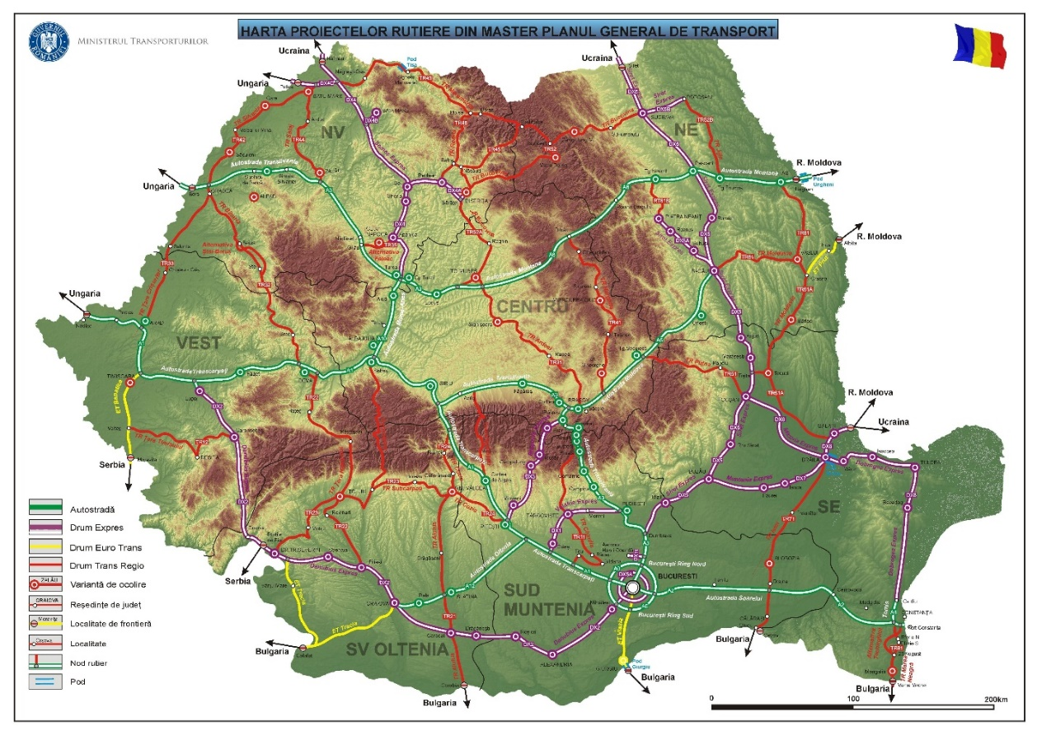
Source: Ministry of Transport, here

Figure no. 9 – Railways, according to MPGT

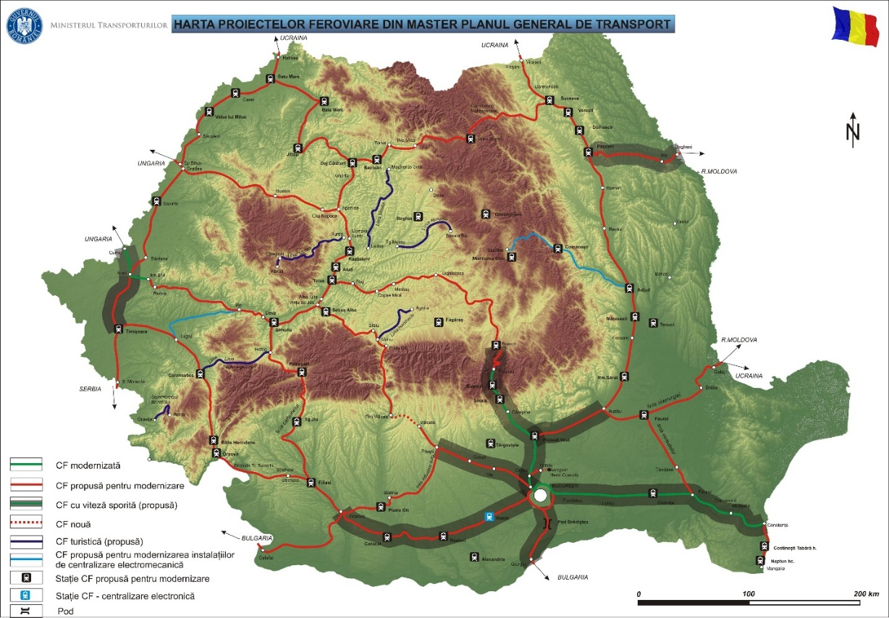
source: Ministry of Transport, here

  - Reducing barriers to 5G network development

Barriers to the development of 5G networks hinder the take-up and increase the prices of services provided on them. To the extent that these barriers are endogenous to investment in mobile communications networks, we will keep working for significantly reducing the level of these barriers by applying concerted measures towards:
- ensuring an optimal mix of frequency spectrum resources for the efficient long-term development of 5G networks, under secure investment conditions;
- ensuring optimal (technical, competition and security) mechanisms for network peering;
- fostering take-up and reducing (tariff and non-tariff related) barriers for access to existing physical infrastructure that can be used by communications networks;
- reducing bureaucratic barriers for building new physical infrastructure, required for supporting communications networks;
- designing, authorizing and executing construction works for roads, motorways and railways with in-built infrastructure facilities for 5G network deployment;
- designing and applying a favourable regime for the installation and use of pico-cells/small cells, including for their fibre-optic connection with backhaul networks.
To this end, in order to stimulate the competitiveness of 5G services, the spectrum resources available below 1 GHz will be used to the utmost extent for public 5G networks.
Moreover, the state of play of public communications network infrastructures in Romania will be assessed and reported at least once every 3 years. We will also use these reports to review public policy on electronic communications infrastructure.
The setup of special or exclusive arrangements for access to essential 5G infrastructures for the purpose of extracting rental fees or building 5G private networks by local public authorities in densely populated urban centres may hinder the development of 5G networks.

  - Promote new uses and foster cooperation

The Internet ecosystem has boomed in the context of the symbiosis between online content providers and providers of communications networks used to carry content to the Internet consumers: the demand for data transmission over the Internet is not determined by the content provider (although it generates the traffic), but by the network provider's users, while the demand for Internet access services that fuels the sales of the network provider is generated by the very success of the online content created by content providers.
In a similar way, it can be deemed that a significant share of the 5G success will depend on the symbiosis between connectivity (network) providers, the providers of online content/Internet 2.0 applications, and the providers of connectable objects/devices/sensors: the connectivity demand benefiting the 5G network provider is rooted in the functionalities, the applications, and in the content created, whereas the value of the content made available through IoT, Internet 2.0, etc., generates the success of these solutions. This principle works for most vertical connectivity scenarios, such as 4.0 industries.

New uses, new connectivity scenarios, bring along important economic and social benefits and also support 5G medium-term growth. Furthermore, 5G's success depends on achieving economies on a larger scale than available in the Romanian market.

Therefore, we pursue promoting new uses and foster cooperation by applying concerted measures aimed at:
- stimulating cross-sectoral cooperation for the 5G technological progress to permeate the whole ecosystem, through the establishment of forums for dialogue, exchange of experience, R&D and testing, which allows for the progress achieved in the Union to be capitalized and enhances the competitive or comparative advantages in the Romanian economic sectors and social life;
- actively supporting the European and international technical standardization processes in communications or in other economic sectors affected by the 5G, as well as the European harmonization of the use of radio frequencies;
- carrying out Romania's intentions to test and trial self-driving and connected vehicles on a large scale in our country, including by joining or initiating a European 5G corridor across one of the national borders;
- facilitating pro-competitive collaboration between the providers of physical infrastructure in different sectors, in order to increase the efficiency of its use;
- the participation of Romanian organizations in the testing and validation of pan-European 5G performance and uses, which should foster the meeting of demand for solutions with the technology-based offer in the synergy of the single internal market.

Figure no. 10 – Cross-border corridors for connected and self-driving vehicles
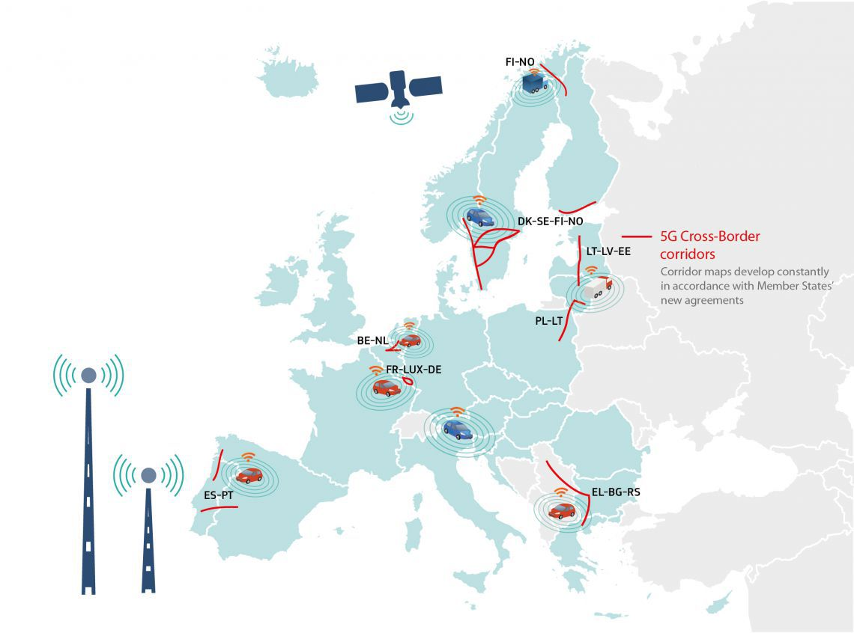
source: European Commission, state of play as of 2018

https://ec.europa.eu/eurostat/statistics-explained/index.php/European_cities_–_the_EU-OECD_functional_urban_area_definition
Trans European Transport Networks (TEN-T), according to Regulation (EU) no. 1315 din 2013 of the European Parliament and of the Council of 11 December 2013 on Union guidelines for the development of the trans-European transport network and repealing Decision No 661/2010/EU (Text with EEA relevance)
to be enumerated during the public consultation
idem footnote 65
Master Plan General de Transport al României, http://mt.gov.ro/web14/strategia-in-transporturi/master-plan-general-transport/documente-master-plan1/1379-master-planul-general-de-transport
idem footnote 66
http://www.mdrap.ro/administratie/-8388
Waze or Fitbit are good examples
http://ec.europa.eu/newsroom/dae/document.cfm?doc_id=43821
see the list of 5G European corridors, https://ec.europa.eu/digital-single-market/en/cross-border-corridors-connected-and-automated-mobility-cam

