Disclaimer: This is a Romanian to English translation meant to facilitate the understanding of this document. Should differences appear between the Romanian and the English version, following translation, the Romanian version shall prevail.

- 5G features

5G is the generic name for a new generation of technologies in the IMT 2020 family, which - through its features and through the innovations it introduces - facilitates the development of genuine digital ecosystems in most sectors of economic and social life.

An extensive characterization of the 5G standardized uses as well as the capabilities and technical requirements for 5G technologies was published by ANCOM in 2017.

  - Multiple types of connectivity

Even though the 5G technical specifications have not yet been finalized in all respects, reviewing the main connectivity use cases illustrates the technical capabilities for which this technology is designed.

    - Significantly better mobile internet

Significant improvement in mobile internet performance is probably the most obvious 5G functionality: ultra-/super-fast indoor and outdoor speeds with constant service quality, for higher data volumes per connected device, with improved coverage, 5G will enable a significantly better mobile connectivity experience for a larger number of users and in a greater number of locations.

The higher capacity of the radio access network allows for increased transfer rates on multiple connections simultaneously, even in high-density areas, such as on public events and at peak traffic time. Higher network speeds allow consumers to view high-definition content, 4K and even 8K in multiple locations, thus supporting live event broadcasting and high-resolution multimedia transmissions.

    - High-speed internet

The superior network performance enabled by 5G opens up new opportunities for the efficient and large-scale provision of high-speed wireless fixed internet services to households or businesses, including by providing cloud computing-based solutions for connecting data and applications in different geographical areas.

The massive increase in network capacity, together with the use of radio frequencies in large blocks (e.g. 50-100 MHz), especially in millimetre wave bands (blocks of hundreds of MHz), will allow for 5G internet solutions to reach speed and latency performance comparable with that ensured by fixed fiber optic networks, and to avoid unnecessary costs with the deployment of local loop cables.

Therefore, although not a separate use case in the ITU vision, given the competition dynamics and specific national circumstances, the fixed high-speed Internet using 5G wireless solutions has a clear potential in Romania.

    - Massive machine-type communications

5G has been designed for a particular connectivity scenario to match the exponential growth of the number and density of connected objects. In fact, it is the first time that the specific connectivity needs of other sectors are provided for in the technological design phase. Massive machine-type communications encompasses mainly all the categories of uses related to industrial digitization, smart transformation of localities along with the emergence of connected objects in all economic sectors, with the development of autonomous systems based on a combination of technologies such as IoT, cloud, artificial intelligence (AI), etc.

These developments are anticipated to bring significant benefits in terms of productivity and value added to products or services, supporting cross-sectoral integration and the emergence of new markets, etc.

Connected objects have typical connectivity requirements that are fundamentally different from those of people: small chunks of data in a low transmission rate, mostly with predictable communication times, generally less sensitive to transmission delay, but require a low power consumption (extended battery life) and extended coverage.

Compared to current technologies, 5G brings the capability of connecting a massive number of such objects with a very dense territorial distribution, and as the 5G networks mature, they will allow the provision of communications infrastructure under flexible and accessible conditions, tailored to the specific needs of to each industry.

    - Mission-critical communications

5G has also been designed for the provision of Ultra-Reliable Low Latency Communications (essentially instantaneous) services, with very high availability, ultra-low jitter or no packet loss.

Mature 5G communications networks will enable operators to provide communications for such mission-critical services as - for example - public safety, the technological ecosystem of autonomous vehicles and transport safety, in remote surgery or in high precision control of industrial processes.
Additional connectivity use cases, fundamentally different from those mentioned above, may also emerge in the future. Such a possibility recommends flexibility in 5G networks so that it can accommodate the typical requirements of new use cases.

  - Technology differentiators

The need to ensure the connectivity use scenarios described above triggers 5G to combine a number of innovative technical capabilities and technologies in different ways. Reviewing the most important of them, with a brief explanation of their role in the context of 5G technology, also helps explain some of the challenges and opportunities associated with the 5G development.

Building on 4G, the 5G technology introduces a plethora of enhancements of the existing performance, as well as new functionalities, in line with the new connectivity trends. Different applications have different quality requirements: from low data rates (e.g. data transmitted by sensors and IoT) to very high speeds (e.g. high-resolution multimedia content) and various delays (e.g. delays are less tolerated in videoconferencing than in video streaming where buffering can be used). Excepting self-driving vehicles, augmented reality and tactile internet, many applications can - at least theoretically - be provided by existing networks. 5G networks will have to meet different service quality requirements for different types of applications (e.g. a few seconds delay may be fatal to a self-driving, connected vehicle).

The achievements expected from 5G networks are summarized in Table no. 2 below, in comparison to current 4G performance.

Table no. 2 – a comparison between 4G and 5G capabilities

Indicator | Description | 4G | 5G
Peak data rate (Gbit/s) | Total traffic per device within one cell | 1 | 20
User experienced data rate (Mbit/s) | Total traffic constantly witnessed by a user | 10 | 100
Spectrum efficiency (bit/s/Hz/site) | Average data throughput | 10 | 15-30
Mobility (km/h) | Maximum speed at which a defined QoS can be achieved | 350 | 500
Latency (ms) | The time from when the source sends a packet to when the destination receives it | 10 | 1
Connection density  (per sq km) | Number of connections per unit area, for which certain quality parameters can be achieved | 100,000 | 1,000,000
Energy efficiency | The radio interface capability to minimize energy consumption | 1x | 100x
Area traffic capacity  (Mbit/s/sq m) | Total traffic throughput served per geographic area | 0.1 | 10
source: ANCOM, based on ITU-R Recommendation M.2083

  - Evolution or revolution

On the one hand, the possible emergence of new ways of providing 5G networks, does not preclude considering a generally accepted scenario for the deployment of 5G networks in Romania and around the world, which is based on existing facilities/networks. In the vast majority of cases, LTE/4G networks are the most advanced mobile communications networks currently in commercial use and are therefore the preferred starting point for the 5G.

On the other hand, even if 5G is considered a disruptive technology both due to the major technological leap and in terms of its capabilities in comparison to 4G, (see Table 2 above), the evolution from one technological generation to another is usually achieved by several intermediate steps and rarely through a single "great jump". Figure no. 7 below shows the release schedule and the 3GPP standard releases during 2017 – 2019.

Figure no. 7 – 3GPP standard releases, 2017 - 2019
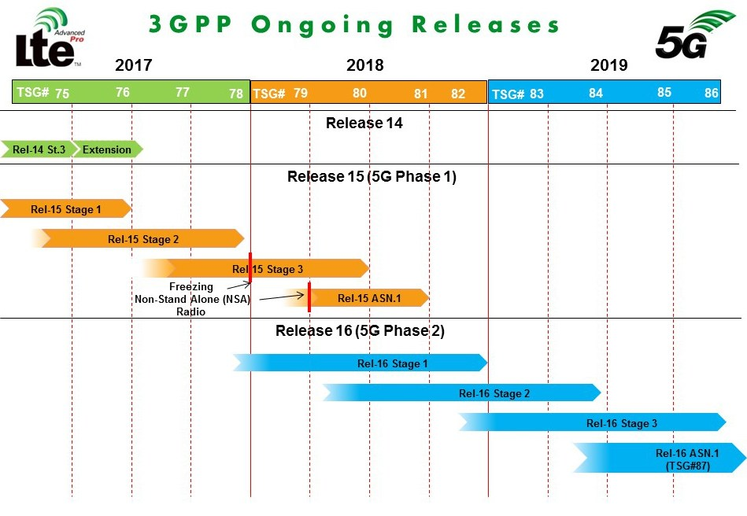
source: www.3gpp.org
For example:
- considering the technical issues, some of the 5G typical features may be achieved by the capabilities introduced by technologies evolved from 4G, respectively editions 13, 14 and 15 of 3GPP standards;
- as shown above, only the 16th release of 3GPP standards, expected in 2019, will enable full compliance with 5G (IMT-2020) requirements; nevertheless, the early launch of “5G” deployments is also possible;
- a similar situation has been registered in the transition from 3G (4th release) to 4G (10th release, the first release of IMT-advanced): the first LTE specifications (3GPPP releases 8 and 9) did not provide for reaching the 4G performance specified by ITU;
- the technical synergies between consecutive releases (intermediate steps, standard releases) and competition between operators in the realm of innovation and network capabilities often drive to commercial naming of networks: a well-known example therefor is HSPA, considered as 4G in USA and 3G+ in Europe.

Co-existence on the network level of several technological generations, and the gradual evolution towards the higher-capability generation has been proven in practice. However, regarding the services to be offered, the difficulties of capitalizing the benefits of the mobile Internet or the uncertainty of capitalizing innovative, IoT-type services must be recognized. From this perspective, long-term incentives for the development of 5G networks depend on the extra revenue that can be gained from new services, from new forms of connectivity.

A reasonable expectation is that, for a considerable period of time, connectivity will be ensured by a technology mix: 5G implemented in dense urban areas in combination with 4G and indoor Wi-Fi connectivity. Therefore, the need for uninterrupted mobile connectivity of commercial products and services will have to be met by multiple technologies: the developer of an application, service or product with built-in connectivity will want to maximize its market by reducing exposure to 5G deployment at different paces from one country to another, using any networks available.

    - What kind of coverage for what connectivity scenarios?

From a space-time perspective, 5G services will not have fixed features but will be the result of choices made by the network operator to meet service demand, within the limits of IMT 2020 standards. The simultaneous provision of all connectivity scenarios (enhanced mobile broadband, low latency fixed Internet, massive machine-type communications and mission-critical communications), on wide areas and at the same time, and in compliance with all the performance indicators in the standards will be particularly onerous.

Therefore, it is more likely to find geographic areas that, although considered to be covered by 5G, actually benefit from some of the technical specifications of IMT-2020 only. Moreover, the mix of technical capabilities available in that geographical area may vary over time, depending on the choices made by the network operator, in response to changes in service demand.

http://www.ancom.org.ro/uploads/forms_files/CONSULTARE_ACORDARE_SPECTRU_700_800_1500__2600_MHz_3,5GHz_revizuit_12_07_20171499848014.pdf
Recommendation ITU-R M.2083-0 – IMT Vision – Framework and overall objectives of the future development of IMT for 2020 and beyond
eMBB – enhanced Mobile Broadband
FWA – fixed wireless access
the limited ubiquity of fixed communications networks, infrastructure-based competition, FWA 5G tests in Romania
mMTC – massive Machine Type Communications
URLLC – Ultra-reliable and Low Latency Communications
A detailed list of new technologies in 5G context is available in Annex 2
e.g. MIMO, beamforming, massive IoT, etc.
also known as 4.9G, or LTE Advanced Pro
e.g. sparsely populated geographical areas may be covered using the 5G standard in terms of satisfying the requirements for mMTC deployments (for example, precision agriculture), while the capacities required for high-speed mobile internet may lack.

