Disclaimer: This is a Romanian to English translation meant to facilitate the understanding of this document. Should differences appear between the Romanian and the English version, following translation, the Romanian version shall prevail.

- A diagnosis of the current situation

Similarly to new networks, strategies are built using and based on the groundwork in place. Therefore, a strategy requires a pertinent diagnosis of the current situation. In the context of the 5G strategy for Romania, the service consumption and the network organisation trends and developments, as well as the dynamics of laying down and planning 5G public policies at the national, European and global levels are highly relevant.

Since the launch of mobile communications in Romania, in 1993, four technology generations have substantially influenced the way people live, work and do business. The latest generation of technology, 4G, launched in Romania in 2012, has been associated with a new trend as regards innovation, devices and the consumption of Internet services.

  - Significant growth potential in the Romanian market

Figure no. 1 – connections and total mobile data traffic in Romania
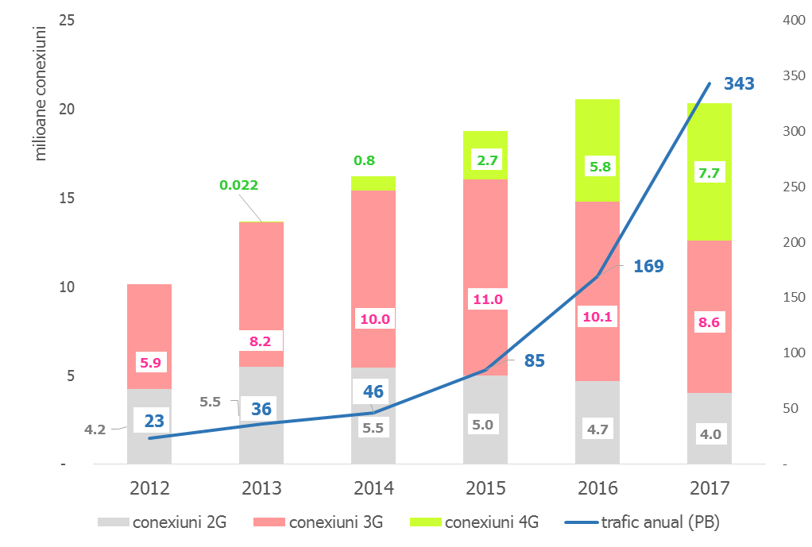
The exponential growth in mobile data traffic recorded given the massive spread of connections on increasingly efficient terminals and the deployment of LTE/4G technology in the mobile networks in Romania is highlighted in Figure no. 1. Actually, mobile data traffic doubled each year in the last four years.

source: ANCOM statistics

Figure no. 2 – 4G/LTE mobile internet coverage (% households)

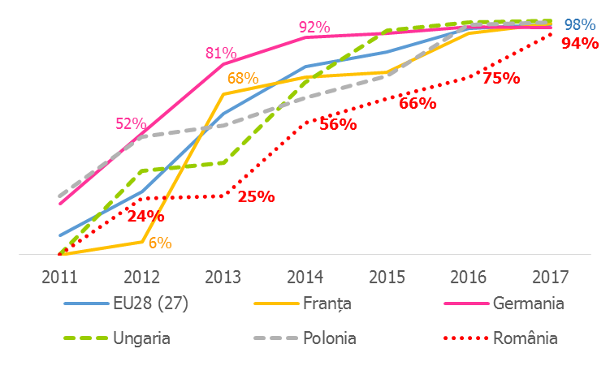
5 years after the competitive selection procedure for awarding frequency use rights organized by the National Authority for Administration and Regulation in Communications (ANCOM) in September 2012, 94% of households in Romania benefited from 4G/LTE network coverage. However, in a European context, this remarkable Romanian performance shows a slower coverage growth rate compared to many Member States, but also brought our country significantly closer to the EU average, only 4 p.p. below.
source: Digital Agenda Scoreboard, European Commission
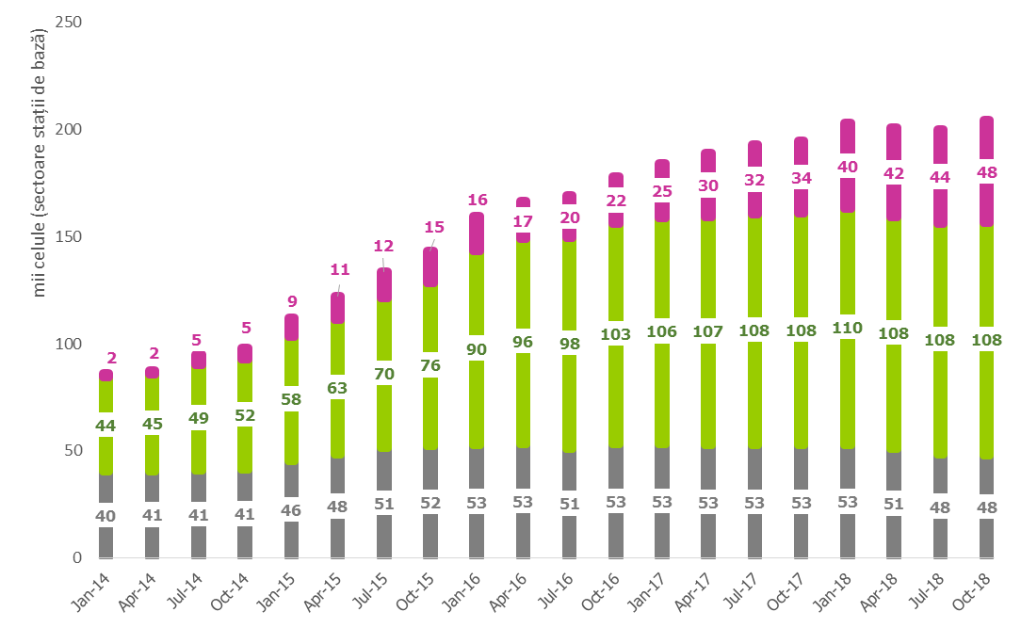

Figure no. 3 – BS sectors (cells) in the Romanian mobile networks
source: ANCOM statistics

Serving the growing demand for services required the densification of the number of sectors (cells) installed on the mobile networks in Romania, by an average annual growth rate of more than 20%. Although the number of 4G cells has witnessed the fastest growth rhythm, 3G cells count more than half in the amount of active cells on mobile communications networks in Romania.
Figure no. 4 below is a graphic representation of Romania's progress on the five directions characterizing the digital transformation of the economy and society, compared to the average progress made at EU level.
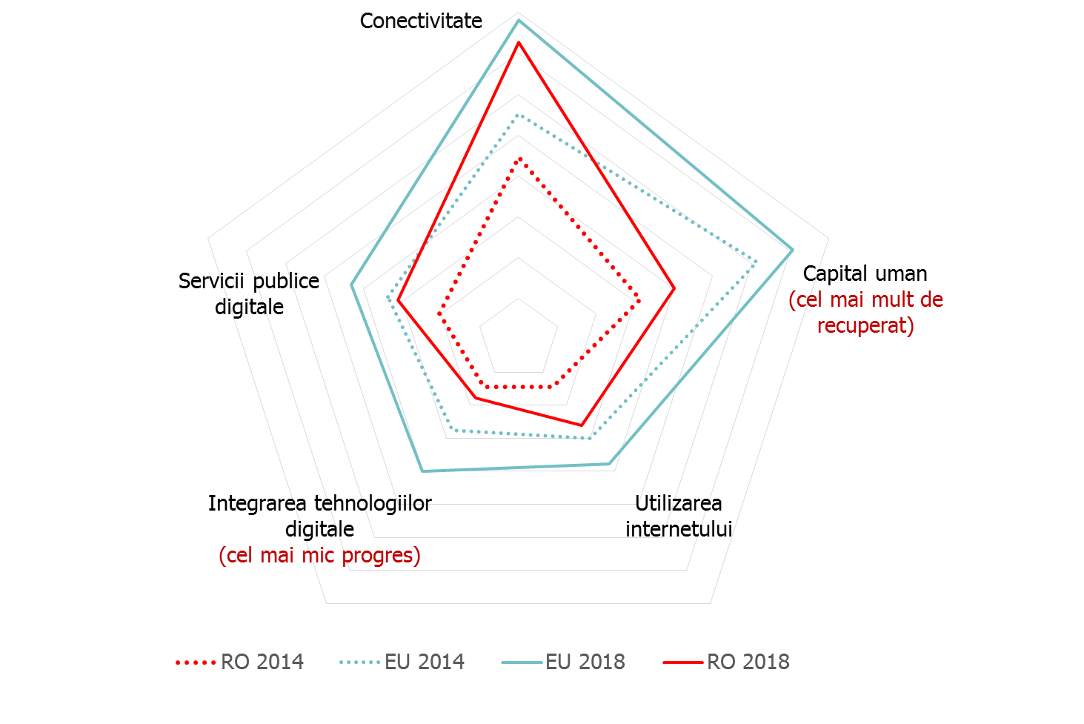
Figure no. 4 – Romaniațs DESI progress
The connectivity benefits are expected to spread gradually and unevenly. Nevertheless, in the past 5 years, Romania’s remarkable connectivity achievements have not been fully capitalized, given the major gap in terms of human capital and the modest development in the integration of digital technologies into economic life. Moreover, the progress registered in the internet use uptake or in the deployment of digital public services can barely bring 2018’s Romania to the EU 2014 average, constantly placing our country at the bottom of the DESI ranking.
source: ANCOM’s representation based on EU’s DESI index

  - Emerging trends in Romania and on the global level

Europe has been a leader in the development and commercialisation of many of the aspects of today's technologies spread on a global level, and Romania greatly benefits from the availability of such technologies. In the presence of advanced technologies, economies and societies develop at an accelerated pace.

A series of emerging trends in the global ICT sector are the engines of growth, innovation, of the rise of new business models, and even of disruption in various economic sectors, and 5G can make a significant contribution to supporting these developments. Below, we summarize the most popular trends.
Connectivity: The data traffic upsurge is due to the massive increase in connectivity demand driven by the proliferation of ever smarter phones and other connected devices. Thus, electronic communications networks progressively become channels for the mass consumption of multimedia content (music, movies, live streaming), for the proliferation of OTTs and for the large-scale use of a wide range of various applications and services (social networks, payment applications and e-commerce) and even for the remote management and control of various types of devices (sensors, video cameras, etc.). If, in the medium term, the increase in connectivity demand will continue to be fuelled by smartphones, tablets and other personal equipment, the potential for long-term data traffic growth is expected to be based primarily on connected objects/things. In this context, the 5G contribution will consist both of improving mobile internet performance and opening new opportunities for serving connected industries with cost effective solutions, speed and energy efficiency.

Ubiquitous internet access: fixed internet solutions provided by mobile operators using wireless networks are an already established method for connecting many households and businesses in Romania, especially where fixed networks are not available. However, current technologies do not allow data download speeds and latency levels typically witnessed in traditional fixed networks, and often do not offer the most advantageous option from an economic perspective. In the 5G context, the attractiveness of fixed internet solutions offered via wireless networks increases substantially due to the availability of radio frequencies and technological progress.
Business digitization increases enterprise productivity and helps increase consumer satisfaction, with a positive effect on turnover. The full 5G benefits are expected to materialize at global level by 2035, when the annual production of 5G-enabled goods and services is forecast to stand at $ 12.3 trillion. Also, advanced data analysis techniques can enable companies to achieve advanced segmentation of markets and consumers, including improved prediction techniques regarding consumer behaviour, thus maximizing value added per customer. The 5G data collection and processing capability is facilitated by edge computing, a functionality that can support certain aspects of advanced data analysis and digitization.

Internet of Things (IoT) is the next major economic and social innovation, after connectivity. IoT allows for any physical (thermostat, bicycle helmet, etc.) or virtual object (representation of an object in a computer system) to be connected to other objects and to the internet, creating a network between objects and between people and objects. IoT can combine physical and virtual worlds into intelligent ecosystems that perceive the environment, analyse and adapt to make our lives easier, safer, more efficient and friendly. The significant increase in the number of connected IoT objects at annual average rates of over 20% by 2022 will be fuelled by a wider range of usage scenarios (cases) and by the lowering prices of connected devices/things. On the other hand, the existing coverage of mobile networks places their operators in a good position to provide the connectivity needed for emerging IoT applications. If alternative technologies, including improvements to 4G services, are sufficient to meet medium-term demand for IoT, 5G brings reliability, low latency, scalability, security and mobility, ingredients that can support the massive proliferation of IoT ecosystems.

Network upgrades: Currently, most of the network upgrades are driven by the need to improve user experience and enhance performance. In the future, upgrades will also be driven by the provision of specialized services for certain vertical industries, but also by the need to meet the demand for network security and integrity for different categories of customers (consumers, business environment, sensitive government services, etc.).

Cyber ​​security and data sovereignty: the IoT proliferation and the possibility to provide more and more industries with customised services determine a growing amount of confidential, and sometimes highly sensitive commercial information, to be carried through communications networks. Due to the heterogeneous possibilities of accessing the network, in combination with advanced data processing and data mining techniques, data loss or illegal use may have severe consequences, including reputational risks that may hamper the development of services. Thus, ensuring the security of communications infrastructures must be reinforced by ensuring the security of services from their design stage, through a user-centered approach. Therefore, 5G is expected to allow scalable identity management, distributed authentication, and secured network segments.
Consolidation, mergers & acquisitions and packaging: Procurement is an attractive means by which communications operators create new product and service offerings beyond their traditional capabilities, and can enter new markets or launch new businesses. We are already witnessing situations where operators pack products and services or expand the range of services they offer beyond the capabilities of their own networks, targeting entry into adjacent industries. The levels of costs and capabilities needed to materialize economies of scale in 5G may foster merger and acquisition plans between network operators, communications companies, and fixed and mobile operators.

  - The global 5G race

Following the numerous research, development and testing processes carried out over the past several years worldwide, including the technological standardization in international and regional organizations, it is generally accepted in the communications industry that the commercial launch of 5G services will take place around 2020. Currently, network providers have gone beyond exploratory phases and are working on understanding how they can best meet the specifications of 5G technology, as well as on identifying the most appropriate technology options for their own networks’ migrating to 5G.

This state of play underpinned ambitious trials and large-scale pilot projects around the world: in August 2018, 154 mobile communications network providers on all continents had already performed or planned to perform demonstrations, tests, or trials of 5G technology. Of these, 67 operators in 39 states have announced that they will market 5G services before 2022.

Romanian communications operators have also conducted several public 5G tests over the past two years, with various objectives: testing transmission capacities and carrier aggregation in different usage scenarios, testing the massive MIMO solution in real time, or testing 5G performance in terms of speed, latency, etc., for mobile internet as well as for fixed wireless internet. Some operators have already announced the commercial launch of 5G services in Romania to take place in 2020.
At European level, the global 5G race accelerates private or public initiatives in different directions. The pace and the multitude of developments in run-up to 5G makes an exhaustive analysis of these developments irrelevant in the context of this strategy.

However, the recently launched European 5G Observatory is a good (non-exhaustive) source of systematic information on recent 5G developments in markets and networks as well as on public initiatives supporting these developments in EU countries and beyond.

Figure no. 5 below illustrate the main milestones achieved and, as the case may be, anticipated in the global and European 5G race from the point of view of standardization, radio spectrum availability, as well as the European and global initiatives and events that can favour the 5G development.

Figure no. 5 – milestones in the global 5G race for
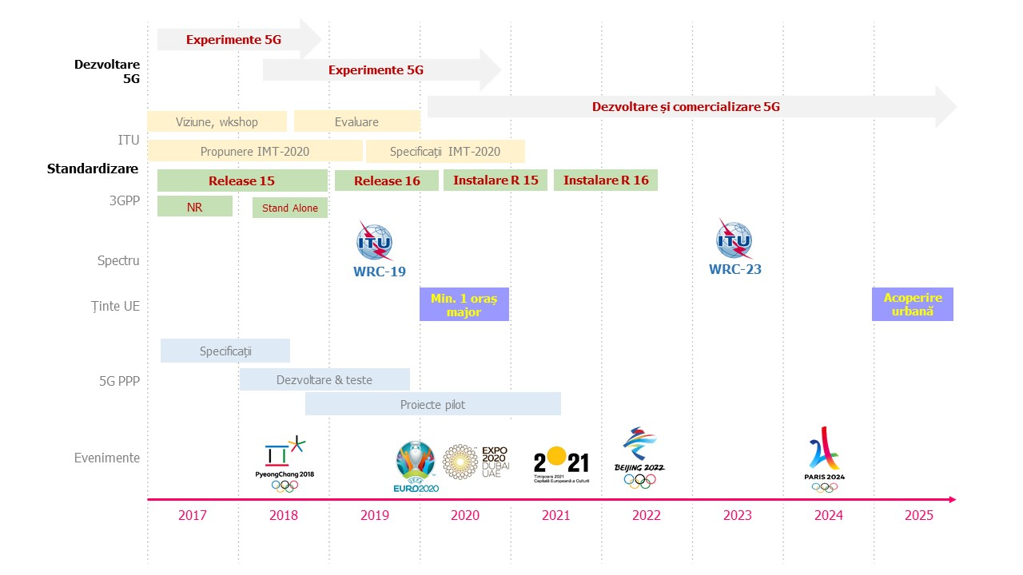
source: ANCOM, based on Dot-econ and publicly available information

Thus, the action plans of relevant standardization bodies, such as ITU and 3GPP, focus on studying technological requirements and adopting standards by 2020. Network technology is already available: 3GPP announced as of December 2017 the completion of the Release 15 of 5G New Radio standard in a critical scenario for network development, depending on existing LTE networks ("non-standalone" scenario), and by mid-2018 the standalone version of new radio networks. It is also anticipated that the first 5G terminals will become available in the first half of 2019.

The completion of 3GPP Release 16, expected in 2019, will allow full compliance with all 5G (IMT-2020) requirements, while marking the second phase in the development of standardized 5G networks.

On the other hand, ITU World Radiocommunication Conferences (WRCs) are vital to materializing the 5G super-speed vision: for example, the WRC-19 conference will focus on the availability and harmonization of the use of new radio spectrum for mobile Internet in several frequency bands between 24.25 GHz and 86 GHz.

Last but not least, the big economies of the world have ambitious roles in the 5G race and rely on major public events such as the Olympic Games or the World Football Championship to support the commercial launch of these services. In Europe, the ambitious targets in the "5G for Europe" roadmap are also supported by the European Commission's co-financing of the 5G-PPP initiative launched in 2013.

  - Developments and trends in 5G public policies

- at European level

The ambitious strategic planning achieved through the Digital Agenda for Europe 2020 gave rise to the connectivity and coverage targets set for 2025 by the document Connectivity for a Single Digital Competitive Market: towards a European Gigabyte Society. In the context of recognizing the importance of very high speed networks such as 5G, at European level, it is foreseen to ensure uninterrupted coverage in cover all urban centers and along the main ground transportation routes by 2025, with an intermediate 2020 target set - the launch of 5G commercial services in at least one major city in each Member State.

Considering the strategic opportunities opened by the new generation technology, the 5G Action Plan for Europe identifies the main challenges and areas that require concerted action coordinated among Member States. Besides contributing to the digital single market and setting their own strategic objectives in the 5G context, Member States should also develop their own "5G Roadmaps" (Action 1) and "consider using the 5G infrastructure to improve the performance of communications services for public safety and security "(Action 7).

Since the adoption of the above-mentioned forward-looking documents, the Member States and the European Parliament have repeatedly shown their support for the overall strategy and objectives proposed: the European Parliament has welcomed the initiative of the European leadership on the development of standardized 5G networks,while Member States have emphasized the common ground of action lines for 5G success and have committed themselves to pursuing the elements of a common roadmap for 5G development.

Moreover, the proposal for a directive on the European Electronic Communications Code, one of the key elements of the Digital Single Market Strategy, has recently been voted in the European Parliament, with the entry into force expected for the end of 2018.

- interactions and synergies with strategies in Romania

Strategic planning in Romania is achieved through several general or sectoral strategies that meet goals, address perspectives and cover different time horizons. These strategies interact when the measures and interventions proposed directly or indirectly target the same area. When strategic approaches complement each other, providing similar development trends for a domain, or building on each other using syncretic instruments, it creates actionable synergies.
The strategic vision and planning in the Romanian communications sector are formulated and detailed in the National Strategy on the Digital Agenda for Romania 2020, as well as in the Program for the roll-out of Next Generation Networks (NGN).

In implementing the above-mentioned relevant national policies and strategies and with a view to efficiently meeting its statutory objectives, ANCOM has laid down and is guided by its Strategy for Digital Communications 2020, paying particular attention to the first key element for carrying out the 5G vision: the frequency spectrum. To this end, ANCOM conducted a public consultation by means of a questionnaire, in 2017, on the principles of granting rights to use the frequencies in 5 radio frequency bands, and adopted the national roadmap on the future of frequency bands with great economic value: 470 - 790 MHz.

Furthermore, the national strategy for the regulation, implementation and optimization of smart-city digital technologies in Romania, currently under development, will provide key strategic guidance for the development of key components for the sustainability of 5G.

The 5G Strategy for Romania has a high potential for capitalizing synergies with national strategies/action plans in force in other sectors. Some synergies are more visible due to specific cross-sector interdependencies (e.g. physical infrastructure, communications, energy, transport), others may be foreseen due to the 5G capacity to infuse mass technology (R&D-innovation, smart specialization) and connectivity in all economic and social sectors (means of transport, commerce, agriculture, construction works, processing and extractive industries, education, health, etc.), thus contributing to development (competitiveness) with positive effects on the environment and social redistribution (reducing gaps). It is noteworthy, however, that further interactions and synergies (e.g. mobility, technological gap between public and private/commercial services) may occur over time and the intensity or action direction of synergies may differ from the currently expected ones.

Figure no. 6 below schematically illustrates the main links with other national strategies/action plans, section 6.3 Preferred uses reviews some 5G solutions in several sectors/areas, and Table no. 1 - The 5G contribution to approaching challenges and meeting sectoral needs was complemented by sector-specific elements, identified upon analysing interactions between relevant national strategies.

Figure no. 6 – the 5G strategy takes into account the following strategies/national plans

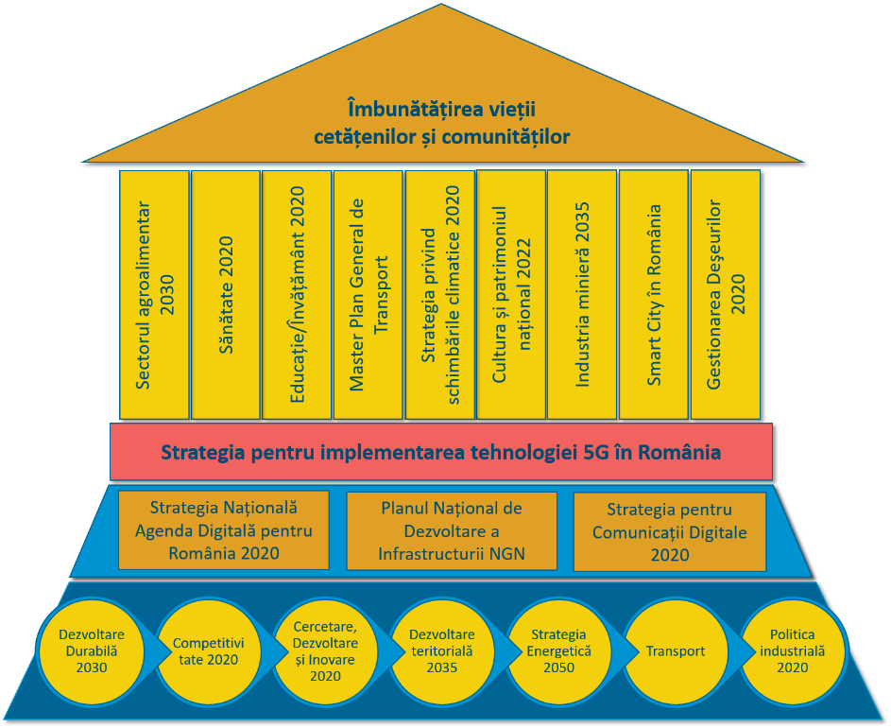

source: GLI-5G

Over The Top – generic term for services enabling the delivery to the end-user of any kind of content (music, movies, telephony, instant messaging, audio-visual broadcasting programmes etc.) over an Internet connection, while avoiding the platforms of traditional providers of such services. Widely-used OTTs in Romania are: Netflix, Mubi, Skype, Whatsapp, YouTube etc.
http://www.adlittle.com/sites/default/files/viewpoints/adl_reimagining_telco_operations_in_a_hyper-digital_world_0.pdf
12.3 trillion USD is approx. The level of overall 2016 consumption expenditure in China, Japan, France, Germany and UK, or China’s 2017 GDP. Source: https://www.qualcomm.com/invention/5g/economy
https://www.ericsson.com/assets/local/mobility-report/documents/2017/ericsson-mobility-report-june-2017.pdf
update or modernization including higher capacities, enhanced functionalities or performance, used in technology- or software-related contexts
data mining
see, for example, connected objects tariff plans or smart home solutions offered by the communicatons operatoirs in Romania
see, for example, the startup accelerator Orange Fab launched in Romania in June 2017, or the acquisition of IoT provider Evotracking by Vodafone Romania
https://gsacom.com/paper/5g-evolution-lte-global-market-status/
https://5g-ppp.eu/5g-trials-2/#1512731004794-672b7993-7792
http://5gobservatory.eu/
International Telecommunicatoions Union
The 3rd Generation Partnership Project
see, for example, https://www.forbes.com/sites/jeanbaptiste/2018/09/18/huawei-confirms-release-of-foldable-screen-5g-smartphone-in-mid-2019/
5G-PPP – The public-private partnership for 5G infrastructures, https://5g-ppp.eu/
final COM (2016) 587, https://ec.europa.eu/transparency/regdoc/rep/1/2016/EN/1-2016-587-EN-F1-1.PDF, and the Staff Working Document of the Commission SWD (2016) 300, https://eur-lex.europa.eu/legal-content/EN/TXT/PDF/?uri=CELEX:52016SC0300&from=EN
highways, national roads, main railway corridors, according to the trans-Europeană transport network
final COM (2016) 588, http://ec.europa.eu/newsroom/dae/document.cfm?doc_id=17131, and the Staff Working Document of the Commission SWD (2016) 306, http://ec.europa.eu/transparency/regdoc/rep/1/2016/EN/1-2016-588-EN-F1-1.PDF
Resolution 2016/2305(INI) of 1 June 2017 on internet connectivity for growth, competitiveness and cohesion: European gigabit society and 5G: http://www.europarl.europa.eu/sides/getDoc.do?pubRef=-//EP//TEXT+REPORT+A8-2017-0184+0+DOC+XML+V0//EN
Common ministerial declaration Making 5G a success for Europe https://www.eu2017.ee/sites/default/files/inline-files/Ministerial%20declaration%205G_final_0.pdf
https://www.mkm.ee/sites/default/files/8.a_b_aob_5g_roadmap_final.pdf
https://www.comunicatii.gov.ro/wp-content/uploads/2016/02/Strategia-Nationala-Agenda-Digitala-pentru-Romania-2020-aprobata-feb-2015.doc
https://www.comunicatii.gov.ro/wp-content/uploads/2016/02/Programul-NGN-aprobat-1-1.doc
http://www.ancom.org.ro/strategia-de-comunica539ii-digitale-2020_5535
Consultation on awarding the spectrum use rights in the frequency bands 694-790 MHz, 791-796 MHz/832-837 MHz, 1452-1492 MHz, 2530-2570 MHz/2650-2690 MHz, 3410-3420 MHz/3510-3520 MHz, 3450-3465 MHz/3550-3565 MHz, http://www.ancom.org.ro/formdata-269-49-322
National Roadmap for the allotment and future use of the 470 – 790 MHz band, http://www.ancom.org.ro/uploads/links_files/Foaia_de_parcurs_pentru_banda_UHF_470-790_MHz_en.pdf
For example, mecatronics, cyber-mixmecatronics, clatronics, programmable robotics are potential uses with impact on the implementation of 5G intelligent systems

